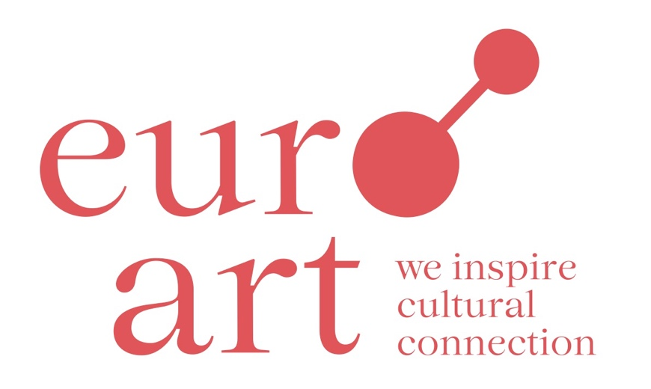

96 members  
in 46 artist colonies

in 12 countries

Welcome!

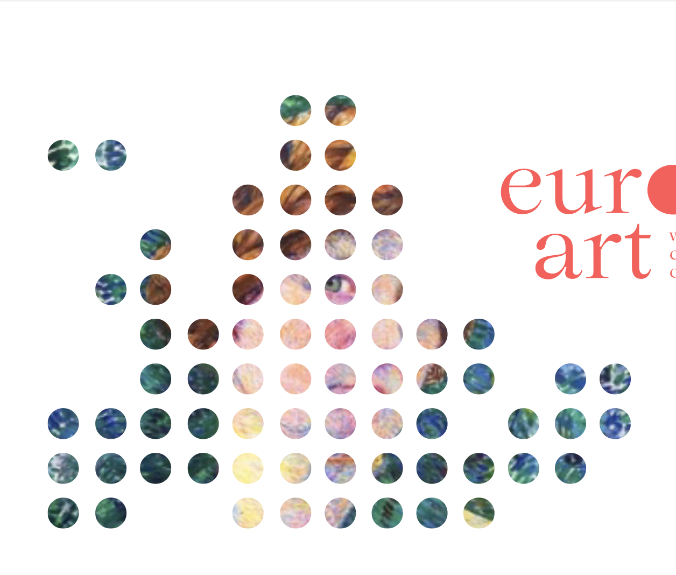

Welcome!

You are now a private member of the euroart network. Please fill out the details below. Feel free to give us any additional information that you think could be useful for us.

Name of the member: ……………………………………………………………….

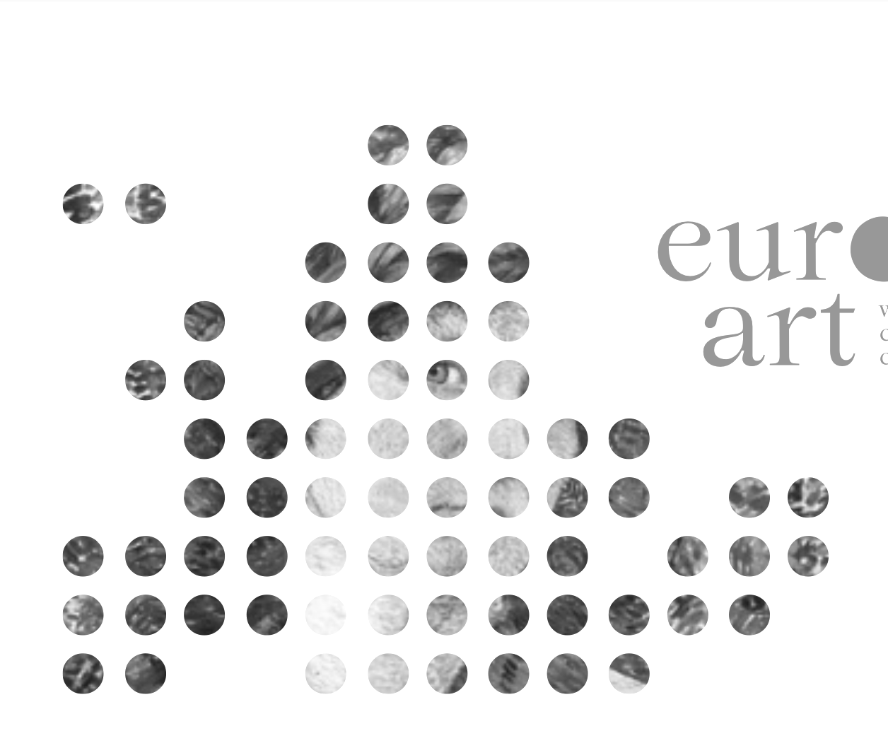Street/number: ………………………………………………………….…………..…

Postal code: …………………………………………………………….………….……

City: ………………………………………………………………………………………..

Country: ………………………..………………………………………..……….………

E-Mail address: ………………………………….……………………..…………...…

Website: ……………………………………………………………………………..……

Any other information you would like to add: …………………………………

………………………………………………………………………………………………..